**Hadaiq Ahmad**

**Cms#112807**

**Gp-1**

**Task 01 and 02**

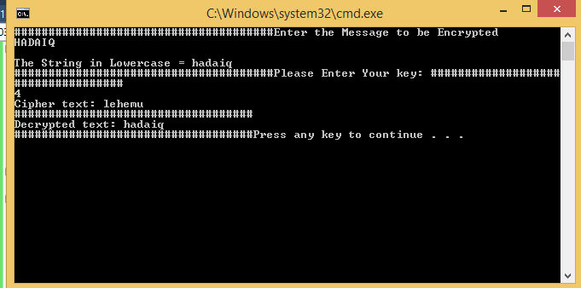

#include<iostream>

#include<conio.h>

#include<string>

using namespace std;

class Ceaser

{

public:

string encode(const string msg, int key)

{

string ciphertext = "";

int normalize = 0;

for (int i = 0; i<msg.length(); i++)

{

if (isalpha(msg[i]))

{

if (islower(msg[i]))

{

normalize = 97;

}

else

{

normalize = 65;

}

ciphertext.push_back((((msg[i]) - normalize) + key) % 26 + normalize);

}

else

{

ciphertext.push_back((msg[i]));

}

}

return ciphertext;

}

string decode(const string ciphertext, int key)

{

string msg = "";

int normalize = 0;

for (int i = 0; i<ciphertext.length(); i++)

{

if (isalpha(ciphertext[i]))

{

if (islower(ciphertext[i]))

{

normalize = 97;

}

else

{

normalize = 65;

}

int m = ((ciphertext[i] - normalize) - key);

if (m < 0)

{

m = 26 + m;

}

msg.push_back(m % 26 + normalize);

}

else

{

msg.push_back((ciphertext[i]));

}

}

return msg;

}

};

int main(void)

{

int key = 0;

Ceaser obj;

char msg[20];

int i;

cout << "######################################";

cout << "Enter the Message to be Encrypted" << endl;

cin >> msg;

for (i = 0;i <= strlen(msg);i++)

{

if (msg[i] >= 65 && msg[i] <= 92)

{

msg[i] = msg[i] + 32;

}

}

cout << "\nThe String in Lowercase = " << msg<<endl;

cout << "######################################";

cout << "Please Enter Your key: ";

cout << "###################################\n";

cin >> key;

string ciphertext = obj.encode(msg, key);

cout << "Cipher text: " << ciphertext << endl;

cout << "###################################\n";

cout << "Decrypted text: " << obj.decode(ciphertext, key) << endl;

cout << "###################################";

system("pause");

return 0;

}

**Task 03**

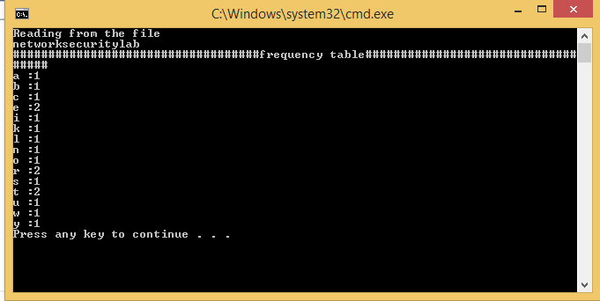

#include <fstream>

#include <iostream>

using namespace std;

class Ceaser

{

public:

int * createFrequency(string data)

{

int * countTable = new int[26];

for (int i = 0; i < 26; i++) countTable[i] = 0;

for (int i = 0; i < data.length(); i++)

{

if (isalpha(data[i]))

{

if (islower(data[i]))

countTable[data[i] - 97]++;

}

}

return countTable;

}

};

int main() {

Ceaser obj;

char data[100];

// open a file in read mode.

ifstream infile;

infile.open("file.txt");

cout << "Reading from the file" << endl;

infile >> data;

// write the data at the screen.

cout << data << endl;

// close the opened file.

infile.close();

int* arr = obj.createFrequency(data);

cout << "###################################";

cout << "frequency table";

cout << "###################################\n";

char a = 97;

for (int i = 0; i<26; i++)

{

if (arr[i]>0)

cout << a << " :" << arr[i] << endl; a++;

}

system("pause");

return 0;

}